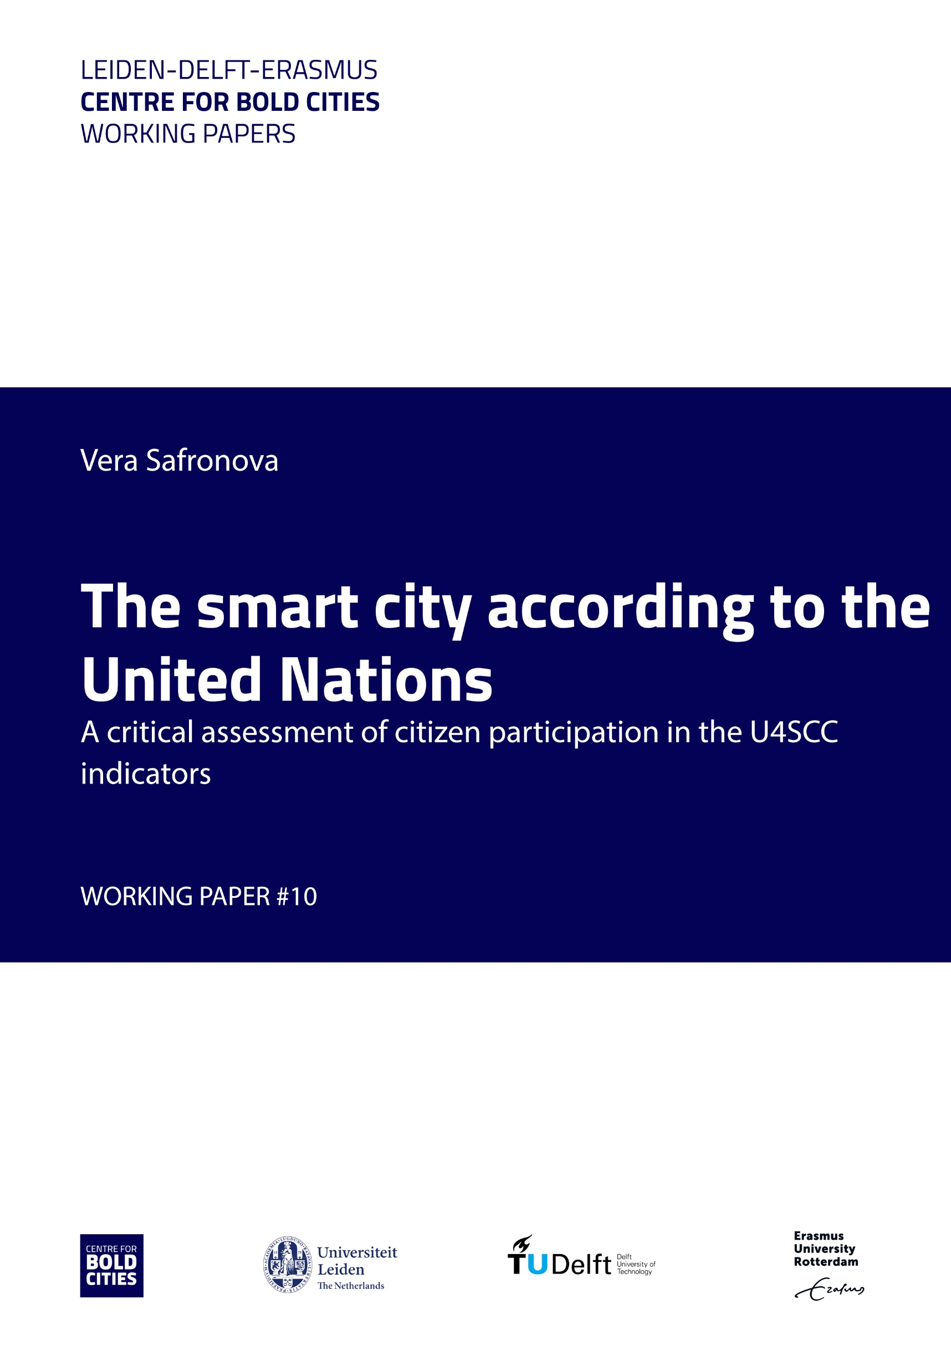

Abstract
Over the past decade, smart cities - cities where modern technologies are used to enhance the quality of urban life - are increasingly suggested as a viable solution to urban issues. The United Nations (UN) is actively involved in smart city projects and their assessment. This paper is concerned with examining whether this international organisation with its clear public remit recognises the importance of citizen participation in the cities of the future. The study analysed the UN’s evaluation of smart cities to see whether it pays attention to citizens’ political opportunities. It concludes that the UN largely excludes residents by making little provisions for their participation in smart city-making, and that the UN basically follows a neo-liberal ideology in assessing the performance of smart city. Three reasons are discussed: the professional background of the staff; the nature of the stakeholder network; and wider smart city ideologies.

I. Introduction

Even though the smart cites concept has been used for about 20 years, it still does not have a commonly accepted definition (cf. Van Waart, Mulder, and de Bont (2015); Mora, Bolici and Deakin (2017). Lai et al. (2020) analysed multiple definitions of smart cities and found that the common feature between them is the focus on enhancing citizens’ living standards with the help of information and communication technologies (ICTs). However, citizens themselves are hardly ever considered to have a possible active role and are not seen as decision-makers on smart cities (Kitchin et al., 2017). This summary of my bachelor thesis (Safranova, 2021) will underpin this claim by analysing the indicators that the United Nations use for smart city assessments. I will explore if such omission of civil engagement standards can be seen as a form of bias that emerges from the neoliberal orientation of organisation (Cardullo & Kitchin, 2019) and the interests of external actors on the smart city assessment (Broz & Hawes, 2006).

This paper is divided into the following sections. Firstly, the literature review presents an overview of arguments about the nature of IOs’ autonomy and common bias in the views of international institutions on smart cities. Secondly, the methods and theories section outlines the guiding scholarly theories which serve as the basis for this analysis, pinpoints the research design, and defines the key concepts. Thirdly, the empirical analysis gives an in-depth study of the UN’s framework on smart cities. This section reveals that its smart city assessment does not contain many indicators on citizen engagement, and neoliberal ideology might be the reason. Lastly, the paper is concluded by presenting the limitations of the research and offering implications of the findings for the UN.

II. Literature review
There is an abundant literature about the administrative and soft powers of international organisations like the UN, but this is primarily related to conventional policy and political issues, and leaves new policy areas like digital and data technologies relatively uncharted. Nevertheless, like other international and national organisations such as the Association of Southeast Asian Nations (ASEAN), European Commission (EC), British Standards Institutions, the UN emphasise that the raison d’être of smart cities is to improve citizens’ lives and well-being (Lai et al., 2020).
However, despite this recognition of citizens’ importance, various researchers (Kitchin et al., 2017; Kostakis, Bauwens, & Niaros, 2015) argue that public opinions and citizen participation are ignored in smart cities debates and practices. According to Kitchin et al. (2017) this is the result of professionals assuming digital technologies are a cure-all that can be utilised to solve any urban issue, disregarding the local opinions. While citizens may not be involved in the design of the smart city itself, digital technologies are increasingly used as means of communication of the local administration and city politics. Shirazi (2009) argues that they can facilitate the wider spread of political information; Vlachokyriakos et al. (2016) state that once city-produced data is available to the citizens, they can have a more active role in setting public agendas. Nevertheless, Webster and Leleux (2020) argue that currently, civic engagement in smart cities is mostly symbolic: residents are needed in such projects only to generate data through the consumption of smart city services. Engelbert, Van Zoonen and Hirzalla (2018) conclude similarly that citizen participation is often a rhetorical device used by state and corporate actors to legitimate smart city policies and practices.

The symbolic and rhetorical nature of current pleas for civic participation in smart cities, becomes even clearer if we analyse the way large expert and international organisations design and assess standards for smart city performance. Citizen engagement is not part of those, as several authors have already argued that large expert organisations create international standards which are used to benchmark functional and technical performances of urban areas (e.g. Lai et al., 2020). Patrão, Moura and de Almeida (2020) conclude that international standards tend to omit an assessment of the smart city contribution to specific local and civic needs. Similarly, Huovila, Bosch, and Airaksinen (2019), as well as Ahvenniemi, Huovila, Pinto-Seppä, and Airaksinen (2017), find a considerable focus on technological indicators of smart cities, at the expense of other ones concerning, for instance, sustainability or participation.

In such a context, the UN, with its status and mission to promote and negotiate human rights, is possibly the only international organisation to assess the civic and participatory agendas of smart cities; it is a role that can be legitimately claimed (by scholars or activists) that the UN should be responsible for. The goal of this paper is therefore threefold. Firstly, it aims to determine whether the UN’s evaluation of smart cities assesses citizen participation. This will be investigated by analysing the newest smart city key performance indicators (KPIs) developed by the U4SSC initiative. Second, using relevant literature we will reflect on possible reasons for the outcomes, and third we will consider ways forward.

Research approach

The research will carry out an in-depth qualitative examination of U4SSC’s Key Performance Indicators (KPI) of smart cities. U4SSC stands for United for Smart Sustainable Cities and it is the only current interdepartmental initiative of the UN that deals with smart cities evaluation. This international initiative incorporates 17 partners constituting various UN agencies.

In order to work on smart cities, in 2016, the U4SSC was launched (U4SSC, 2019a). The International Telecommunication Union (ITU) and the UN Economic Commission for Europe are the core founders of the U4SSC. All its activities aim at providing guidance on achieving SSC in accordance with the SDGs (U4SSC, 2019a). Moreover, it evaluates smart cities by designing a set of international KPIs. KPIs were designed so that cities can measure their progress over time and compare their performance to other urban areas. They are distinguished as ‘core’ (“those that should be able to be reported on by all cities”) and ‘advanced’ which “provide a more in depth view of a city but may be beyond the current capabilities of some cities to report or implement” (idem). The indicators are furthermore divided into three broad subject areas: Economy, environment as well as society and culture. Within each dimension, there are subdivisions that evaluate specific domains of performance. This paper will examine whether these indicators can be associated with measuring the levels of civic participation in smart cities.

The research is based on the documents and reports issued by the U4SSC about the methodologies and logics behind the KPIs, and will be subject to qualitative content analysis. This includes examining latent meanings emerging from the presence and absence of particular terms and relations in the text, in addition to analysing what is being said manifestly about various forms of citizen participation.

Constructing the smart city through KPIs

1. Economic focus
Two sets of results reveal a clear and limited economic focus in the way the U4SSC understands a smart city and its technologies.

The first one concerns its definition, which reads as follows:

“A smart sustainable city is an innovative city that uses information and communication technologies (ICTs) and other means to improve quality of life, efficiency of urban operation and services, and competitiveness, while ensuring that it meets the needs of present and future generations with respect to economic, social, environmental as well as cultural aspects.” (U4SSC, 2020a, p. 4).

This definition can be roughly divided into two parts. The first section emphasises the role of ICTs for improving urban challenges. The second highlights the needs that should be maintained and respected in doing so. Both sections are highly generic and do not identify particular priorities, groups or stakeholders involved. The presence of the term competitiveness, in combination with the ‘economic’ needs of future generations being listed first, clearly indicates a market orientation of U4SSC, which is furthermore suggested by the absence of terms like public or civic.

A second set of results revealing the particular economic of U4SCC’s understanding of smart cities come from the analysis of the document “Collection methodology for Key Performance Indicators for Smart Sustainable Cities” (U4SSC, 2017a). The 91 KPIs currently developed are categorised as economic, environmental and socio-cultural indicators. The economic KPIs make up more than half of all indicators and are presented first, before the environmental (15 indicators) and socio-cultural indicators (27) are. In addition, several indicators measuring the access of citizens to smart technologies are listed under the heading ‘economic KPIs’, suggesting that there is first and foremost an economic benefit of having such access. There are only three (out of the 91) KPIs directly measuring the civic dimensions of the smart city: these are open data, e-government (both categorized as ‘economic’ KPIs) and voter participation (as part of the socio-cultural collection).

2. Absence of citizen participation
All indicators have a brief description in the methodology document which demonstrates in more detail how U4SSC understands citizen participation.
Open data is presented as an ‘advanced indicator’ which means that U4SCC assumes it may not be tenable for all cities. It is about the facilitation of “government transparency, accountability and public participation in government” (U4SSC, 2017a, p. 29). It should be measured by the percentage and number of inventorised open datasets that are published, which, in addition to the participatory benefits, are also expected to “enable economic growth through technological innovation by the private sector (idem).” The civic relevance of open data is thus accompanied by economic expectations.
E-government is also an ‘advanced indicator’ and is defined as the “number of public services delivered through electronic means” (2017a, p. 30). Its aim should be to create more effective public services as well as increase transparency and accountability of governmental institutions (U4SSC, 2017a). The increase of public participation in local decision-making is another value highlighted in this KPI. Yet, the instruction for measuring this KPI is limited to “counting the number of public services available through online service”, which in practice removes the participation value.
Voter participation is the only KPI among these three indicators for citizen participation that is considered ‘core’ and thus essential to smart cities. It is listed as a socio-cultural indicator and is defined as voter turnout in local elections. U4SCC justifies this particular understanding of voter participation by claiming that “a high percentage is desirable in a democracy because it increases the chance that the political system reflects the will of a large number of individuals, and that the government enjoys a high degree of legitimacy.” The measure is thus less useful for totalitarian regimes or failing local democracies.

This analysis shows that apart from voting in local elections, the U4SSC does not consider citizen participation a core performance indicator for smart cities. Moreover, e-government is in its operationalisation defined as ‘service delivery’ rather than as participation. Open data is as much hailed for its civic as for its economic potential. It thus seems safe to conclude that citizens engagement is largely absent from the U4SCC indicators.

3. Citizens as consumers
These outcomes do not only demonstrate the absence of civic participation in the KPIs defined by U4SSC, they also, implicitly, show how it looks at people living in smart cities; as consumers and recipients rather than as citizens. This speaks from the language of ‘meeting needs’ in the definition of the smart city; from the absence of civic participation indicators among the 91 KPIs; and from the understanding of e-government as ‘delivering services’ and of open data contributing to economic growth.

We find such a construction of people as consumers also in other policy documents of U4SCC.
In the “Accelerating city transformation using frontier technologies” report, the organisation defines future cities as “urban agglomerations that harness the power of frontier technologies” (U4SSC, 2020b, p. 1, italics by author). The same document claims that the Internet, as a critical technology of a smart city, will primarily allow citizens’ participation in the economic activities of the cities (U4SSC, 2020b, italics by author). Finally, the most explicit construction of citizens as consumers comes from the “Enhancing innovation and participation in smart and sustainable cities” report that explicitly states that citizens are consumers of smart city solutions: “smart, sustainable city solutions ultimately address and meet the needs of people living in a city (as consumers of solutions) …” (U4SSC, 2017c, p. 108, italics by authors).

In addition to framing citizens as consumers, other policy documents turn them into the generic category of ‘stakeholders’. For instance, the “Enhancing innovation and participation in smart and sustainable cities” report stresses that urban stakeholders should participate in SSC in order to “catalyse and foster innovation capacity” (U4SSC, 2017c, p. 5). This, however, seems to refer as much to the tech and innovation communities in a city as it may to everyday city dwellers.

There is only one instance among the U4SSC reports that does recognise the importance of citizen participation. The paper titled “Implementing sustainable development goal 11 by connecting sustainability policies and urban-planning practices through ICTs” outlines several recommendations for strategic urban planning practices (U4SSC, 2017b). One of them is “fostering community, individual participation and inclusiveness” (U4SSC, 2017b, p. 15). To implement this, the U4SSC recommends setting up mechanisms that would facilitate civic engagement and adopt new city investments only once these underwent participatory budgeting procedures. These provisions promote not only civic engagement but also political participation in the form of participatory budgeting. However, this is the only instance showcasing the U4SSC’s support for citizen engagement in smart city governance.

4. Explanations
How can this specific understanding of smart cities as economic entities in which technologies provide solutions and services for citizens to be consumed be explained? We could examine the ever widening circles of making these KPIs’, looking at the authors of the documents and the KPIs first, then at the wider set of stakeholders around U4SCC and finally consider the dominant discourse about smart cities.

The staff responsible for developing the KPIs are an international team consisting of professionals holding business and technology degrees (U4SSC, 2017a). While this particular background does not prevent a thorough understanding of the need for civic participation in smart cities, it is likely that their community of peers and practice adheres to a discourse that prioritizes economic and technological dimensions. Kitchin (et al. 2017) speaks in this respect of ‘epistemic communities’ in which particular discourses are normalizing certain understanding at the expense of alternative views. Even if there is an awareness of such alternatives, the question of how to seriously include and integrate them, in for instance more diverse KPIs, is more difficult to handle.

What is the wider stakeholder network around the U4SCC? In the Terms of Reference it is mentioned that participation is open for stakeholders outside the UN system (U4SSC, 2019a), especially cities wanting to assess their levels of smartness and sustainability. It also stimulates the formation of public-private partnerships in which both start-ups and multinationals can collaborate with cities and universities, “to create a one-of-a-kind-hub”. It is further evidence of the economic focus of U4SSC that the first country hub has been established by a national economic centre. The three types of partners in the hub (business, government, knowledge institutes) constitute the classic triple helix of innovation, which is often criticized for not including citizens or civic groups. We thus recognize a blind spot among stakeholders as much as among the professionals of the U4SCC.

Finally, there is the wider discursive and operational environment of smart city technologies that will have affected the economic dominance in the U4SCC framework and absence of civic participation as a relevant performance indicator. This is not a one-dimensional environment that inevitably positions the smart city as an economic entity. In fact, the particular approach we have identified and analysed, is part of an Anglo-American understanding of smart cities as places of innovation and economic growth primarily. This fits the wider market model of technology development in these countries, as opposed to the state-driven innovations of China, and the efforts of European cities and the EU to find a middle ground based on public values (cf. Van Dijk et al., 2018). Such a difference between, what are usually called neo-liberal, state and public models, respectively, has been established as typifying smart city ideologies and practices as well (Van Zoonen, 2020). Yet, why it is that this UN initiative, with its roots in Anglo-American, Chinese and European nations alike, has bent so much to the neo-liberal version of smart cities is unclear.

Conclusion
Our analysis has proven sufficient ground to identify the U4SCC as a neo-liberal exercise for cities to assess their smartness. This supports the claim by Cardullo and Kitchin (2019) that supra-national organisations are forms that promote a neoliberal consumerist type of citizenship that largely ignores participation in a city and in city-making. This is particularly striking for a set of indicators produced under the flag of the United Nations, which has a shared mission to bring nations (and their various understandings of societies and markets) together, and to harness human rights and freedom. One would expect its key performance indicators (for whatever policy terrain) to represent a balanced collection of these understandings rather than to promote a particular, Anglo-American and neo-liberal one. There are many resources to consider additional and alternative indicators that represent civic participation better than the three current ones used in the U4SCC set, even within the own UN community. Goals and indicators from the UN-Habitat’s flagship program, “People-centred smart cities” (UN-Habitat, 2019) or Participation Index for Cities and Municipalities (World Forum for Democracy, 2016) can serve as examples of initiatives that focus on fostering better political opportunities for citizens in (smart) cities. These provide a beneficial point of conversation for staff and stakeholders alike, in order to help cities improve their performance in the civic aspects of smart cities as well.

References

Ahvenniemi, H., Huovila, A., Pinto-Seppä, I., & Airaksinen, M. (2017). What are the differences between sustainable and smart cities? Cities, 60, 234-245.
Broz, J., & Hawes, M. (2006). US domestic politics and International Monetary Fund policy. In D. Hawkins, D. Lake, D. Nielson, & M. Tierney (Eds.), Delegation and Agency in International Organizations (pp. 77-106). Cambridge, UK: Cambridge University Press.
Cardullo, P., & Kitchin, R. (2019). Smart urbanism and smart citizenship: The neoliberal logic of ‘citizen-focused’ smart cities in Europe. Environment and Planning C: Politics and Space, 37(5), 813-830.
Cardullo, P. (2021). Citizens in the ‘smart city’: Participation, co-production, governance. London, UK: Routledge.
Van Dijck, J., Poell, T., & De Waal, M. (2018). The platform society: Public values in a connective world. Oxford University Press.
Engelbert, J., van Zoonen, L., & Hirzalla, F. (2019). Excluding citizens from the European smart city: The discourse practices of pursuing and granting smartness. Technological Forecasting and Social Change, 142, 347-353.
Huovila, A., Bosch, P., & Airaksinen, M. (2019). Comparative analysis of standardized indicators for Smart sustainable cities: What indicators and standards to use and when? Cities, 89, 141-153.
Kitchin, R., Colette, C., Evans, L., Heaphy, L., & Mac Donncha, D. (2017). Smart cities, urban technocrats, epistemic communities and advocacy coalitions. The Programmable City Working Paper 26.
Kostakis, V., Bauwens, M., & Niaros, V. (2015). Urban reconfiguration after the emergence of peer-to-peer infrastructure: Four future scenarios with an impact on smart cities. In D. Arya (Ed.), Smart Cities as Democratic Ecologies (pp. 116-124). London, UK: Palgrave Macmillan.
Kumar, T. V. (2017). State of the art of e-democracy for Smart Cities. In E-Democracy for Smart Cities (pp. 1-47). Basingstoke, UK: Springer Nature.
Lai, C. S., Jia, Y., Dong, Z., Wang, D., Tao, Y., Lai, Q. H., … Lai, L. L. (2020). A review of technical standards for smart cities. Clean Technologies, 2(3), 290-310.
Mora, L., Bolici, R., & Deakin, M. (2017). The first two decades of smart-city research: A bibliometric analysis. Journal of Urban Technology, 24(1), 3-27.
Patrão, C., Moura, P., & de Almeida, A. T. (2020). Review of smart city assessment tools. Smart Cities, 3, 1117-1132.
Ruso, J., Horvat, A., & Maričić, M. (2019). Do international standards influence the development of smart regions and cities? Zbornik Radova Ekonomskog Fakultet Au Rijeci, 37(2), 629-652.
United for Smart Sustainable Cities. (2019). U4SSC Key Performance Indicators for Smart Sustainable Cities (PowerPoint presentation). Retrieved form: https://www.itu.int/ en/ITU-T/ssc/united/Pages/U4SSC-info.aspx
Van Waart, P., Mulder, I., & De Bont, C. (2015). A Participatory approach for envisioning a smart city. Social Science Computer Review, 34(6), 708-723.
Vlachokyriakos, V., Crivellaro, C., Le Dantec, C. A., Gordon, E., Wright, P., & Olivier, P. (2016). Digital Civics: Citizen empowerment with and through technology. Proceedings of the 2016 CHI Conference Extended Abstracts on Human Factors in Computing Systems - CHI EA’ 16, 1096-1099.
World Forum for Democracy. (2016). Participatory democracy index for cities. Retrieved from: https://go.coe.int/gQIJZ
Van Zoonen, L. (2020). Public values or public conflict: democratic foundations for the smart city. BOLD Cities Working Paper, #8, https://www.centre-for-bold-cities.nl/working-paper-8-public-values-or-public-conflict-democratic-foundations-for-the-smart-city

https://u4ssc.itu.int/u4ssc-hub/

